**Creating a Report with Power BI Desktop**

**Demonstration Steps**

Create a Report with Power BI Desktop

1. On the taskbar, click **Power BI Desktop**.
2. In the **Power BI Desktop** window, click **Get data**.
3. In the **Get Data** dialog box, click **SQL Server Database**, and then click **Connect**.
4. Server : localhost
5. Database : **AdventureWorks**
6. Data Connectivity mode : import
7. Expand **Advanced options**.
8. copy the scripts from **M2 Ex1 - Power BI.sql** file.
9. In the Power BI Desktop, paste the query into the **SQL statement (optional, requires database)** box, and then click **OK**.

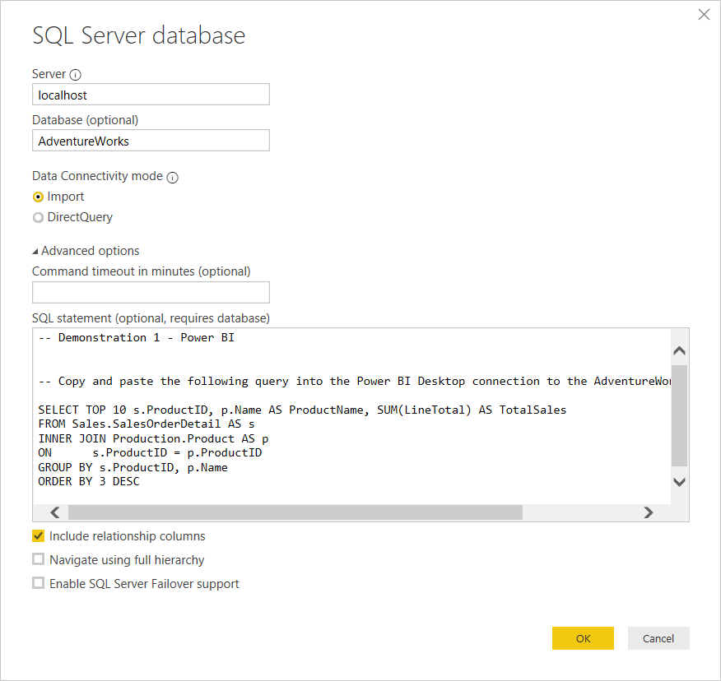

1. The data preview window will appear, click **Load**.
2. If the **Connection Settings** window opens, leave **Import** selected, and click **OK**.
3. In the **Visualizations** pane, click **Stacked column chart**.
4. In the **Fields** pane, under **Query1**, select **ProductName** and **TotalSales**. The chart will auto populate. Expand the chart control to horizontally show the full names of the products.
5. In the **Visualizations** pane, click **Format**.
6. Expand **Title**, and change the **Title Text** value to **Top 10 Selling Products**.
7. Next to **Alignment**, click the **center** icon.
8. Toggle **Data labels** to be **On**.
9. Expand the **Data colors** list, and choose another color to change the bars on the chart.
10. On the **File** menu, click **Save As**. Name the report **Adventure Works Sales**, and save to the **C:\Demofiles\Mod02\Demo** folder.
11. Leave Power BI Desktop and the report open for the next demonstration.